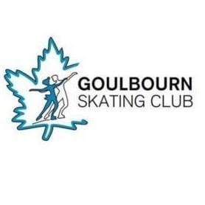

Goulbourn Skating Club

Meeting Code of Conduct

The Goulbourn Skating Club has created this Meeting Code of Conduct to ensure that club meetings run smoothly while adhering to GSC By-Laws. Members participating in all meetings of the club must conform to the following guidelines.

- When entering and during the meeting, members will ensure that their microphone is muted.
- Members will use the Raised-Hand feature of the platform if they would like the floor.
- Only Voting-Members can be acknowledged by the moderator as per the By-Laws section 2.11.
- Disruptive or inappropriate behaviour will not be tolerated and may result in removal from the meeting.
- For all in favour votes, members will type “yea” or “nay” in the comments section.
For motions they wish to second, they will type “second”.

